
scvs
SERVICES AVAILABLE

Implementation
Maintenance
Application Support
Audit & Investigative Analytics




S
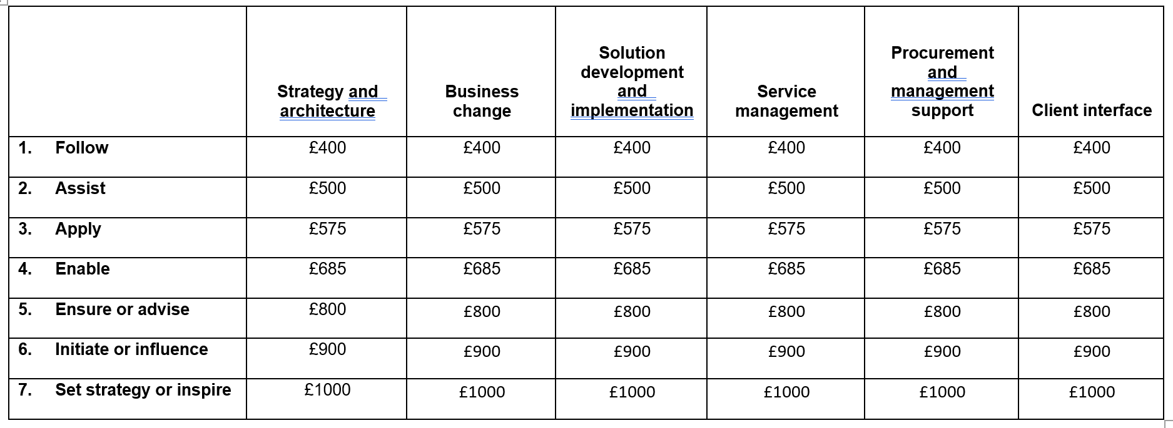
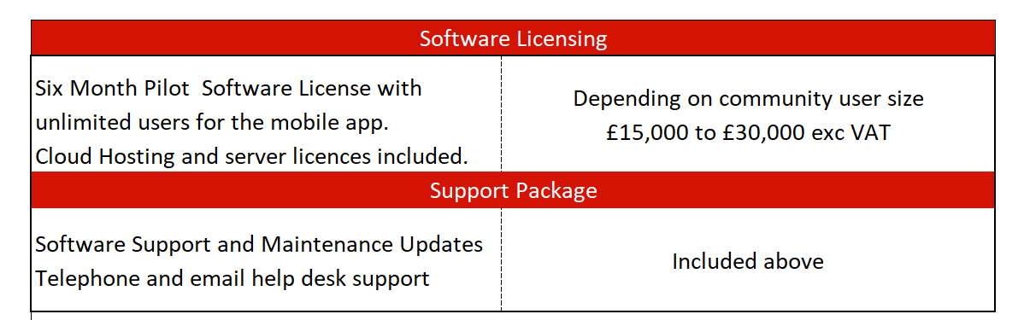
Pricing Information
www.constentum.com
facebook.com/constentum

twitter.com/@constentum
Standard SFIA Rate Card
Consultant’s Working Day – 7.5 hours exclusive of travel and lunch
Working Week – Monday to Friday excluding national holidays
Office Hours - 9am to 6pm Monday to Friday
Travel, mileage Subsistence – Included in day rate within M25. Payable at department’s standard T&S rates outside M25
Mileage – As above
Professional Indemnity Insurance – included in day rate

