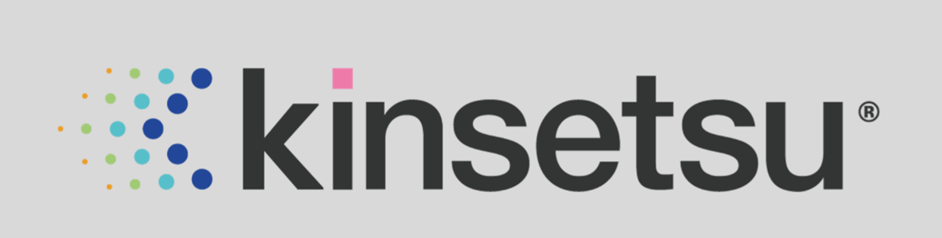

Transform
Automate
Innovate

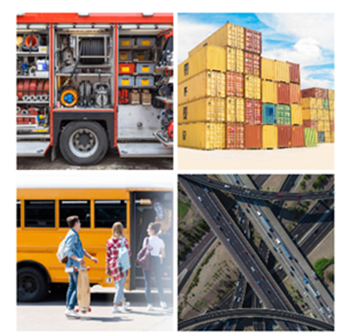
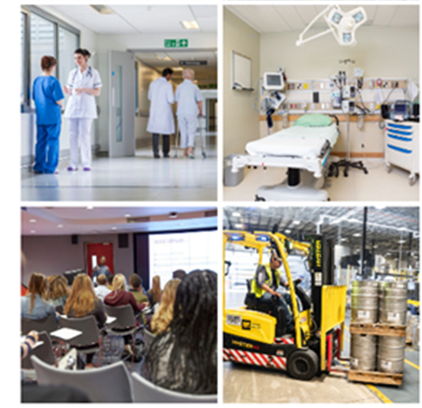

Providing intelligent tracking solutions to help organisations automate and optimise tasks and services, improving safety, reducing risk and ensuring compliance.

G Cloud Service Description
May 2019
Why Kinsetsu?
Kinsetsu is a Belfast-based software and Internet of Things (IoT) company that helps organisations gain real-time insight about the assets they value most, bringing knowledge, experience and a strategic approach.
By using a wide array of sensors and diverse connectivity technologies we create intelligent asset management models which help our customers reduce costs and overheads associated with managing these assets. So, whether you want to understand patient flow within a hospital’s Accident & Emergency department, monitor a student’s journey when using school transport, be alerted to an asset that is due for warranty and its location, or just identity available equipment for a job list, we can do all of this in real-time from a single intelligent solution.
We utilise technologies such as RFID, Bluetooth, GPS, Wi-Fi, 4G and Sigfox recognising that every geographic location brings its own unique connectivity challenge. We select the right sensor for an asset type and material including metals, wood, plastics, concrete, or using in water, or on roads, cognisant that assets may be static or mobile.
Our solutions are secure, scalable and Cloud based.

What we do
Kinsetsu brings knowledge, experience and a strategic approach; we create and enable IoT strategies, building a digital bridge between your critical assets and your business systems, automating and validating your processes to empower decision making and improve productivity.
IoT solutions help organisations transform by creating more efficient delivery models, reducing the costs associated with intensive manual processes. Gaining strategic benefit from IoT investment requires careful planning and analysis to avoid end-point solutions, data islands and non-enterprise ready technology.
We automate and optimise paper-based and manual tasks using sensors to capture data, reducing the time to complete daily tasks to seconds and enabling you to reclaim valuable time.

Where we work
Kinsetsu delivers solutions across Healthcare, Government, Education, Agriculture, Utilities, Manufacturing and the Commercial sector across the UK and Ireland.
Our solutions range from tracking healthcare records, school buses, electrical components and lighting sub-structures, patients, domiciliary care workers, manufacturing silages, freight containers, clinical equipment and hospital beds.

Designed to Automate

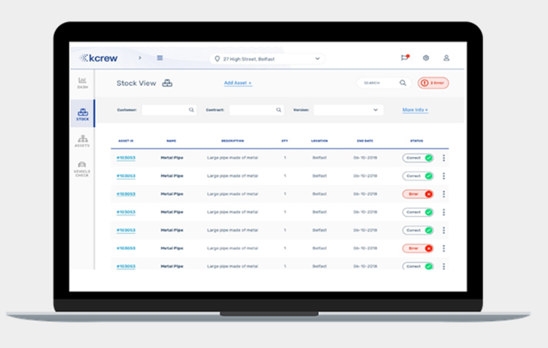
kcrew is an automated job readiness solution that checks that all equipment, tools or parts are available, replacing paper-based manual checking and reducing time to complete tasks to seconds.
Kcrew checks that all equipment and assets are ready and available to be utilised, whether in hospital ward or lab, depot, vehicle or remote customer site.
kcrew captures regulatory and compliance information and provides alerts on sub-optimal asset status.
For vehicle-based field crews the solution also ensures only what is required for the day is on the vehicle, avoiding overloading and unnecessary reordering of equipment, reducing fuel utilisation and ensuring no repeat visits to sites due to missing or defective equipment.
kcrew is being used by field engineering teams, ambulance and fire crews to check vehicles for job readiness during shift-changeover. It is also being used in a healthcare setting for theatre readiness.
Service Features:
- Automated alerting for warranty, maintenance tasks and key dates
- Real Time Location Services (RTLS)
- LoRa, Sigfox, Zigbee, BLE, Wi-Fi, GPS and environmental sensor networks
- RFID, Facial Recognition, Iris Scan, Cameras, Biometrics, Access Control,
- Smart Cities, Smart Agriculture, Smart Health, Smart Transport, Smart Office
- RFID tags, proximity cards, proximity readers, biometric readers

Service Benefits:
- Optimises work flow and drives better staff utilisation and savings
- Real time reporting and analytics capability

Real Time Management

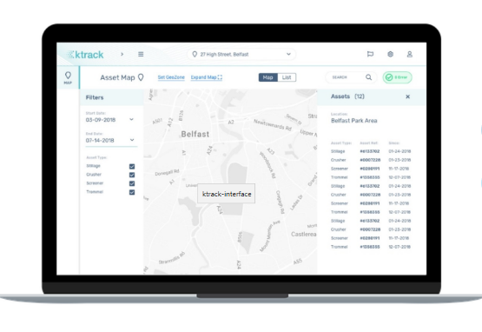
ktrack is an intelligent asset tracking solution that tracks hundreds and thousands of assets in real-time, removing the reliance on manual processes and paper-based records.
ktrack monitors and tracks equipment, people, plant and machinery or inventory unobtrusively, enabling increased productivity.
ktrack uses digital mapping to visually display a map view of an asset’s physical location, providing the quickest route to retrieve an asset.
ktrack provides auditability of assets helping you gain an understanding of asset flow relevant to service timelines and priorities within a building, a boundary or within a region.
ktrack is being used to monitor and track a diverse range of assets including paper hospital records, school transport, school pupils, electrical components and lighting sub-structures, generators, parts and equipment, patients moving around hospitals, domiciliary care workers arriving in client homes, manufacturing silages, freight containers, clinical equipment and hospital beds.
Service Features:
- Real-time asset management with a mobile version for field crews
- Provides incident notifications so that any problems can be audited
- Notifications and alerts on asset status (email and SMS)
- Customisable mapping of locations, zones, colours, asset types and people
- Tracks movement of critical assets and people within any location
- Modular platform which is scalable and easy to use
- LoRa, Sigfox, Zigbee, BLE, Wi-Fi, GPS and environmental sensor networks
- RFID, Facial Recognition, Iris Scan, Cameras, Biometrics, Access Control
- Smart Cities, Smart Agriculture, Smart Health, Smart Transport, Smart Office
- RFID tags, proximity cards, proximity readers, biometric readers.
Service Benefits:
- Real Time reporting
- Improves visibility, tracking assets in real-time
- Removes reliance on manual processes for validation
- Optimises work flow and drives better staff utilisation.


Designed for Digital Traceability and Wayfinding

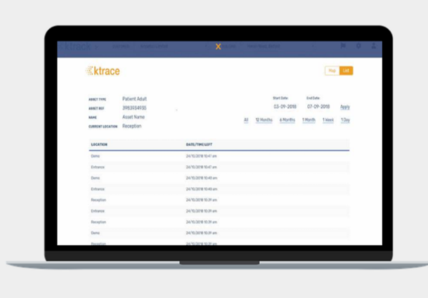
ktrace is a powerful audit trail solution that enhances the intelligent tracking functionality of ktrack. ktrace provides historical traceability of all managed assets, locations, durations etc. for the last day, week, month, year, or across the lifetime of an asset.
Ktrace automates manual processes used to trace assets and asset journeys, reducing the amount of time spent capturing this information.
Ktrace generates a meaningful dashboard view of critical KPI metrics and enables trend modelling for assets, providing real-time information to inform business decisions.
ktrace is being used together with ktrack in about 60% of the client use cases we service today, where the client needs to understand the asset journeys across its lifetime.
Service Features:
- Powerful digital mapping/signposting to locations or misplaced assets
- Provides a digital footprint of where an asset has been
- Provides powerful data analytics and critical service metrics
- Quick Search function to locate key assets
- Value-added data including, alerts and changes in asset status
- Intelligent asset tracking
- LoRa, Sigfox, Zigbee, BLE, Wi-Fi, GPS and environmental sensor networks
- RFID, Facial Recognition, Iris Scan, Cameras, Biometrics, Access Control
- Smart Cities, Smart Agriculture, Smart Health, Smart Transport, Smart Office
- RFID tags, proximity cards, proximity readers, biometric readers.
Service Benefits:
- Automated traceability and wayfinding
- Blends digital connectivity, mapping and visualisation platforms for seamless traceability
- Significantly reduce staff-time spent tracing asset journeys
- Save on search time with an easy search function
- Real-time reporting.

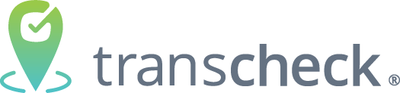
Designed for Safer and
Optimised Transportation

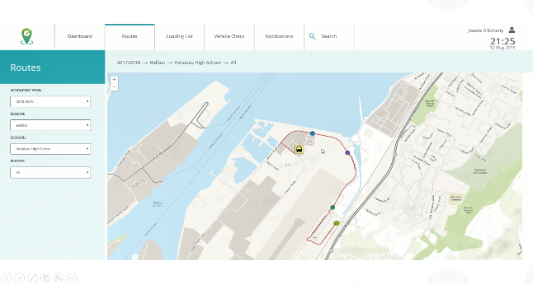
transcheck provides enhanced fleet and/or passenger management and safety by seamlessly recording the presence of passengers as they enter/exit transport and tracking their journey.
transcheck provides and a real-time digital footprint of the fleet and/or passenger journey enabling a meaningful pick-up time from bus stops for parents/guardians/carers.
transcheck delivers automated alerts and notifications to ensure compliance for vehicle checking.
Historical data can map trends to facilitate route, seat and fuel optimisation.
transcheck is being used to manage private fleets for hospital and school transport. It is also being used for passenger management of school pupils.
Service Features:
- Utilises various 'Smart' technologies and automation
- Provides better management of private passenger transport services
- Real-time information of transport services
- Utilises geozone passenger pickup, journey and incident alerting
- Data is seamlessly captured, manipulated and analysed to drive improvements
- LoRa, Sigfox, Zigbee, BLE, Wi-Fi, GPS and environmental sensor networks
- RFID, Facial Recognition, Iris Scan, Cameras, Biometrics, Access Control
- Smart Cities, Smart Agriculture, Smart Health, Smart Transport, Smart Office
- RFID tags, proximity cards, proximity readers, biometric readers.
Service Benefits:
- Designed for Safer and Optimised Transportation
- Improving fleet logistics
- Understand usage patterns
- Full visibility of every journey by student, by route and by school
- Enables better communication of real-time information
- Safer and more efficient transport services
- Replaces paper-based manual checking and reduces time taken to seconds
- Real-time reports.

Internet of Things (IoT) Strategy, Implementation and Support Services
Consulting, design and development services for IoT projects.
Kinsetsu supports our customers to connect devices and sensors to the cloud and collects, collates and analyses their data
Kinsetsu’s technical IoT expertise supports our clients to design, create and rollout innovative digital solutions to connect people and objects, utilising the smart device, sensor and IoT landscape.
Kinsetsu provides IoT consulting services to enable organisations to gain real-time insight about the assets they value most. Using sensors and connectivity we create more efficient delivery models, reducing the costs associated with often labour-intensive manual processes.
Kinsetsu brings knowledge, experience and a strategic approach to help our customers successfully introduce IoT and achieve an early return on investment.
Features:
- IoT Innovation and Business Case Development
- Designing and building /or joining IoT infrastructure
- Planning, building, developing, testing and rolling out cloud IoT solutions.
- Selection of IoT devices, tools, software and services
- Proof of concept demonstrating feasibility and added value
- LoRa, Sigfox, Zigbee, BLE, Wi-Fi, GPS and environmental sensor networks
- In-depth knowledge and proven experience of IOT domain
- Device management, Data management, analytics, visualisation and reporting
- RFID, Facial Recognition, Iris Scan, Cameras, Biometrics, Access Control,
- Smart Cities, Smart Agriculture, Smart Health, Smart Transport, Smart Office
- RFID tags, proximity cards, proximity readers, biometric readers

Benefits:
- Clear understanding of IoT and developing investment business cases
- Delivery of business objectives and return on investment
- Ensuring compliance with security and quality standards
- Business innovation and service design using IoT technology
- Specialist skills and experience from our specialist team
- Rapidly build and deploy IoT solutions and services
Smart Spaces
Kinsetsu supports our clients to design, create and rollout intelligent solutions to seamlessly connect teams, workspaces, ideas and partners. We help optimise workplace resources using technologies such as biometric access control with time and attendance functionality (facial and fingerprint recognition), interactive meeting room booking panels, hot-desk booking systems, intelligent CCTV (facial, demographic and automatic number plate recognition - ANPR), wireless presentation, digital signage and touchscreen room control systems.
Kinsetsu provides consulting, design and development services intelligent office and workspaces.
Kinsetsu supports our customers to integrate smart space technologies into new and existing environments.
Kinsetsu provides Smart Space consulting services to enable organisations to gain real-time insight about the assets they value most.
Kinsetsu brings knowledge, experience and a strategic approach to help our customers successfully introduce Smart Space technologies and achieve an early return on investment.
Service Features:
- Time and attendance management
- Meeting space optimisation via interactive meeting room and hot-desk booking panels
- Integrate Wireless presentation and Cloud based digital signage
- Intelligent CCTV (facial, demographic, and automatic number plate recognition)
- Internal wayfinding solutions
- RFID, Facial Recognition, Iris Scan, Cameras, Biometrics, Access Control
- Smart Cities, Smart Agriculture, Smart Health, Smart Transport, Smart Office
- RFID tags, proximity cards, proximity readers, biometric readers.
Service Benefits:
- Flexibility and availability of office Space, optimising resource usage
- Helps foster an innovative and creative working environment
- Detailed analytics and Insight into resource utilisation
- Enhanced Security & Compliance
- Seamless, touch panel operation for executive presentations
- Increased staff engagement and improved communication
- Safer working environment
- Reduction in workplace risks through environmental quality monitoring
- Improved employee effectiveness
- Promotion of harmonious workplace- environment.
IoT Connectivity
Kinsetsu provides a comprehensive range of IoT device cloud connectivity support services.
Kinsetsu understands that our customers are focused on delivering innovative IoT projects and outcomes, not necessarily on managing connectivity.
Kinsetsu connectivity services simplify management, improve control, ensure improved insights and ensure the delivery of enhanced returns on investment.
Kinsetsu works with our customers to understand their requirements and to develop the ideal connectivity services for their IoT projects.
Kinsetsu enables IoT devices to connect straight out of the box regardless of geography, network operator or wireless technology.
Kinsetsu provides our customers with a secure and future-proof connectivity service that is easy to adopt, integrate and scale. We enable connections to personnel and assets no matter where they are in the world.
Features:
- Workshops to identify the opportunity for your organisation
- Assist with conceptual IoT solution design
- Align solution development to use case requirements
- Assist in ecosystem development of supporting suppliers
- Cost optimisation and business case development
- LoRa, Sigfox, Zigbee, BLE, Wi-Fi, GPS and environmental sensor networks
- Copper, fibre and cabling support and installation
- RFID, Facial Recognition, Iris Scan, Cameras, Biometrics, Access Control
- Smart Cities, Smart Agriculture, Smart Health, Smart Transport, Smart Office
- RFID tags, proximity cards, proximity readers, biometric readers.

Benefits:
- Clearly identify the financial benefits of 5G and other connectivity
- Delivers a model that is financially sustainable/profitable.

